TC-CMS-027
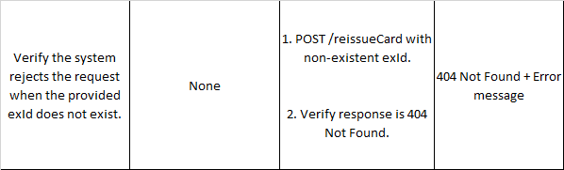
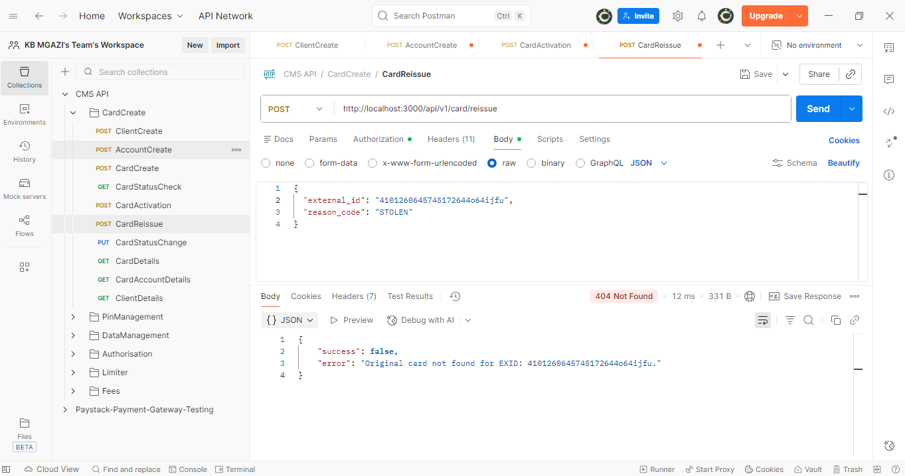
Request:
{
"external_id": "4101260645745172644o64ijfu",
"reason_code": "STOLEN"
}

Response:
{
"success": false,
"error": "Original card not found for EXID: 4101260645745172644o64ijfu."
}

